You Are What You Eat

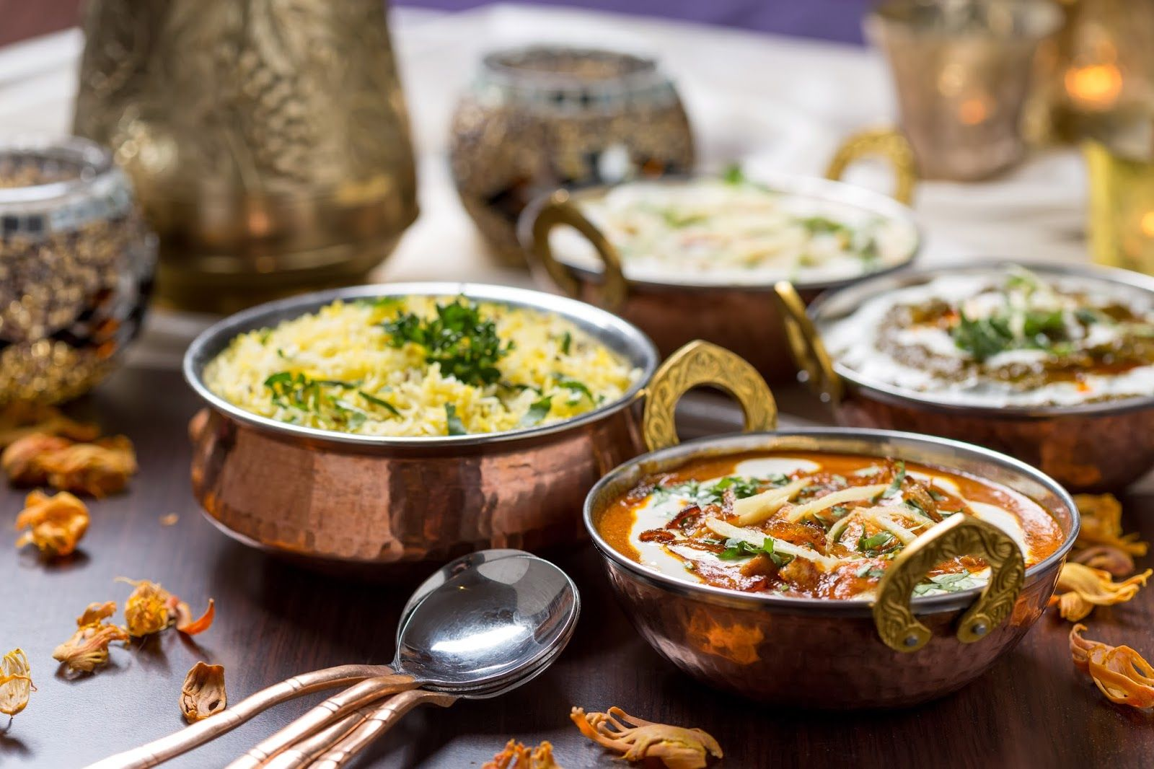

“You are what you eat” this is what we have heard and what we hear on a regular basis. Health is the most precious gift bestowed upon us and we tend to ignore the signs our body gives regarding our health.

When I was a kid, there was no complications or confusions regarding food, eat what was served was the only mantra. Whereas these days, the topic food has been made very complicated. There are number of diets and varieties of food available in the market which is overwhelming. The ignorance towards the principles of healthy life is the main cause for ill health. Most of the health problems are caused due to poor food habits and poor lifestyles. Balanced diet, adequate exercise and mental equilibrium leads to a happy and healthy life.

We eat today judging the food by its appearance, taste and convenience rather than understanding its health factor. This habit becomes difficult to change or adjust at later stage, hence cultivating a good eating habit from an early stage is very important. The sooner we start the better. Eating refined, processed and preserved food became a day to day habit for many without even realizing that this would be the reason for many health issues. The word Diet now has been just limited to weight loss or muscle gain. The importance of nutrients, vitamins, antioxidants, fiber, carbohydrates, probiotics have been generously ignored. A balanced diet is very important to maintain all the vital functions of the body and to improve immunity against common diseases.

## Here are some healthy tips to eat right:

1. Plan your meals ahead- We always end up having outside food or unhealthy food when we are hungry, so plan your meals in advance. Carry healthy snacks while traveling for work.
2. Eating right- Always focus on your food while eating, chew them thoroughly, eat only when hungry and always check the portion size.
3. Drink water- Always have water instead of sodas or sugary juices, they might spike your energy levels the moment you have them but then result in causing lethargy.

Remember, we eat to live a healthy life, the food that goes to our body is going to decide how healthy we would be in coming years. So always think, plan and make healthy choices.