Chia seeds are tiny black or white seeds derived from the *Salvia hispanica* plant, a member of the mint family native to Central America. These small seeds have been a part of human diets for over 5,000 years.

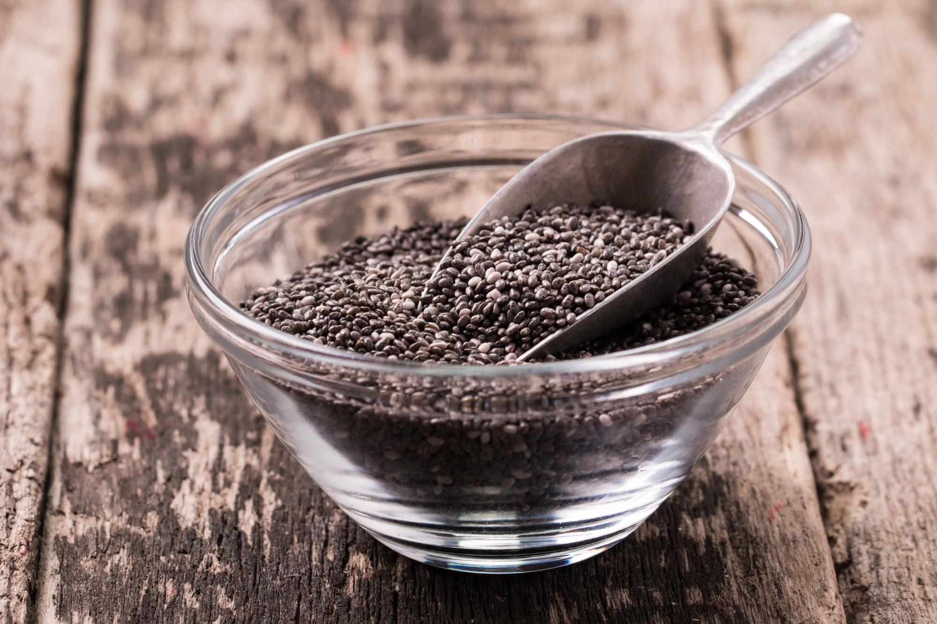

## Health benefits of chia seeds

Chia seeds are packed with nutrients that may support numerous health benefits. Among them:

* Reducing [blood pressure](https://www.health.harvard.edu/topics/blood-pressure)
* Lowering cholesterol levels
* Supporting digestive health
* Aiding in weight management
* Reducing [inflammation](https://www.health.harvard.edu/nutrition/fighting-inflammation-with-food)
* Helping to control [diabetes](https://www.health.harvard.edu/topics/diabetes)
* Protecting against chronic disease
* Improving anxiety and [depression](https://www.health.harvard.edu/topics/depression).

Chia seeds contain a variety of [nutrients](https://fdc.nal.usda.gov/fdc-app.html#/food-details/170554/nutrients) including **fiber, protein, omega-3 fatty acids, antioxidants, and various vitamins and minerals like calcium, magnesium, and phosphorus** that are beneficial to your health.

### Omega-3 fatty acids

Chia seeds are a powerhouse of **omega-3 fatty acids**. This type of fatty acid is primarily found in fatty fish, nuts, and seeds.

Omega-3 fatty acids play an important role in brain function, heart health, and reducing inflammation in the body. Incorporating omega-3s into the diet promotes overall well-being, benefiting cardiovascular and cognitive functions.

Chia seeds are rich in a type of omega-3 fatty acid known as **alpha-linolenic acid** (**ALA**). The body cannot produce **ALA** its own, so it must be obtained through food. Consuming **ALA** has been linked to a decreased heart disease risk.

### Fiber

Incorporating chia seeds into your diet is also an excellent way to increase your intake of [**fiber**](https://www.health.harvard.edu/staying-healthy/fabulous-fiber). Just one ounce of chia seeds (two to three tablespoons) provides approximately 9.8 grams of dietary fiber.

Research has shown that adequate fiber intake is associated with a decreased risk of:

* [coronary heart disease](https://www.health.harvard.edu/topics/heart-disease)
* type 2 diabetes
* several types of cancer
* inflammation
* digestive disorders.

On the heart health front, fiber helps **lower LDL ("bad")**[**cholesterol**](https://www.health.harvard.edu/staying-healthy/a-closer-look-at-good-cholesterol)**and triglyceride levels, and helps increase levels of heart-protective HDL cholesterol.**

The fiber in chia seeds can also aid healthy digestion by softening the stool and providing bulk to it. This allows the stool to pass more quickly through the intestines and can help alleviate constipation.

### Antioxidants

Chia seeds are packed with antioxidants including **tocopherols, phytosterols, carotenoids, and polyphenolic** compounds. Antioxidants play a crucial role in protecting the body from damage caused by free radicals, which can build up in the body and lead to cell damage and disease.

* inflammation
* diabetes
* cancer
* heart disease
* Alzheimer's disease.

### Protein

Chia seeds are also a valuable source of protein. Chia seeds contain all nine essential amino acids. The [protein](https://www.health.harvard.edu/blog/how-much-protein-do-you-need-every-day-201506188096) in chia seeds can help stabilize blood sugar levels and provide a steady source of energy.

## How to incorporate chia seeds into your diet

It's very easy to incorporate chia seeds into your diet. You can simply sprinkle a tablespoon or two on foods such as yogurt, cereal, or salads. You can add chia seeds to smoothies or soups, or mix them into pancake batter or another [breakfast food](https://www.health.harvard.edu/heart-health/build-a-better-breakfast). Chia seeds have a mild flavor, so they are not likely to affect the taste of your food.

